Editing KAT collected Files
By Chuck Keyser
(credit to Milan Markovitch)

Milan has written a long document explaining his perspective on Style and STS files, and I FINALLY understand his problems, and how to work around. The credit for this document should go to him; I am merely paraphrasing what he told me in his own words

(The discussion below is restricted to the Style Tracks, 9,10,11, and 12-16)

First a little background. I have long felt that one of the major uses for KAT would be to be able to edit a complete style at one go in SONAR using Milan's Collected files. There were some bugs we fixed, but the main one is not so much a bug as a concept:

A KAT "collected" file contains all the midi file from each track for each variation in the style; once a collected file is created from KAT, you can drag/drop the file into SONAR and see the file completely laid out, provided you set the MIDI channels to correspond to those of the PA80; you should be able to loop the file and here it played back on the PA80 using its instruments.

There were two issues:

First, the instruments did not show up in KAT the way they were reflected on the LCD screen (if changed from the original)

The answer is that all the style tracks are stored for each variation, but apparently the Style structure only stores one version (the original). but writes the changed version to an STS block; Kat can see the former, but not the latter.

For example, I changed the Menuetto style drum kits from OrchestraK/JazzBrushh to ArabianKits 1 and 2, but KAT ONLY sees them as the former. However, ArabianKits 1 and 2 will be saved and restored to the styles for realtime playing; the settings are just not visible UNTIL KORG PARTS WITH ITS FRIGGING KEYS....

So if a created style is changed, only the original settings will appear in KAT and SONAR.

Second, on looping the tracks, the instruments would always reset to the original, even if the track instruments were properly set at the MIDI inputs to each track. This is a result of the first problem, and the one that was stopping KAT from being a useful tool for programming styles.

HOWEVER there is an answer. In the MIDI events list for each style element/track, there is a setting for the bank/patch that can be changed for each mdi track, and will be saved/restored for the MIDI file.

Apparently it doesn't affect the file when converted back again; the Style appears as it should (i.e., as "changed" in the PA-80) That is, if the Track was ArabianKit1 on the PA80 before editing the Midi in SONAR, it will still be Arabian Kit one after converting it back - changing it to hear looping in SONAR doesn't affect the output file.

So - to use collected files in SONAR:

(assuming you have imported the instrument definitions into SONAR and set them to the appropriate MIDI channel in Sonar/Options/Instruments/....

1. Convert the Style to MIDI using KAT.
2. Drag/drop the midi file into SONAR.
3. Set the bank/instrument for each track/MIDI input channel to reflect those of the PA80; you might have to select an instrument/drum kit, but the banks should be OK.

At this point, I was under the impression that this should be enough. Silly me!

4. Set the instruments for the track/variation you are going to work on in the MIDI Event list. (in SONAR this will be in yelllow. Do this for each instrument you want to hear on using the MIDI out to the PA80.
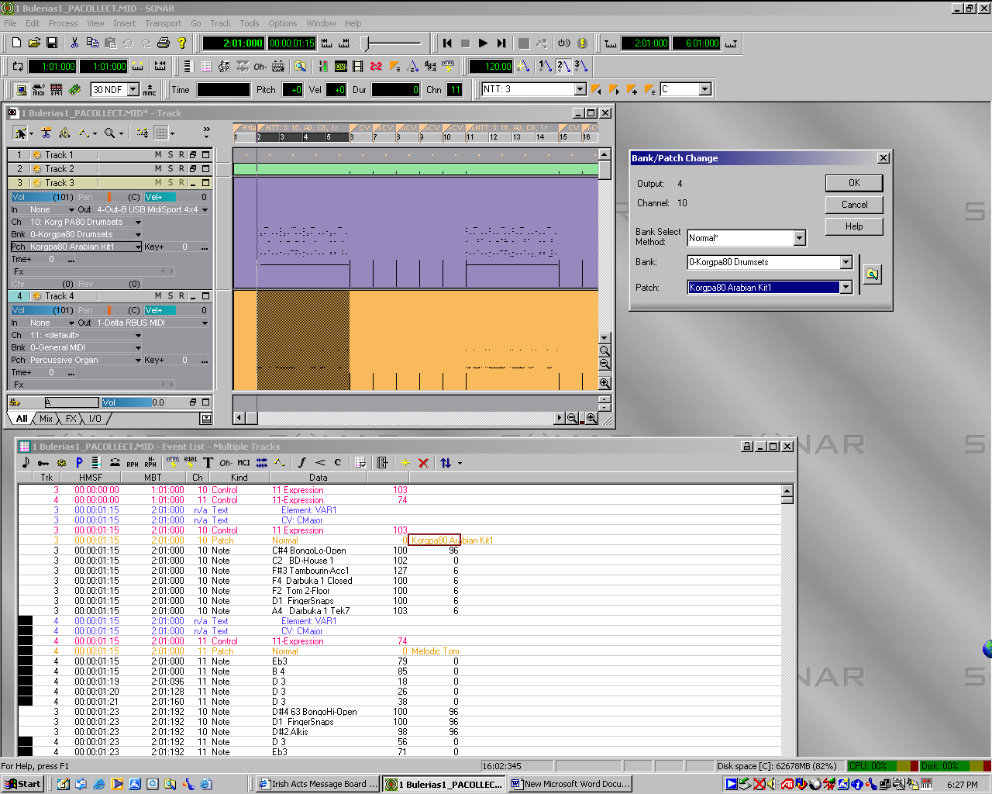

5. Now you can loop on the style element, editing the notes in the piano roll, inserting, etc. using all of SONAR's tools. (if you copy ONLY midi events, you can cut/paste within tracks.), and the PA80 will trigger using the instruments its LCD screen.

I have actually tried this at least once, and it worked...:-)

